**Internship Completion Report**

**Role: Data Science Developer Intern**

**Company: NullClasses**

**Introduction:** The internship report outlines the activities and achievements during the internship period focused on developing various real-time emotion detection systems. The primary objectives included identifying wrinkles on faces, building emotion detection models using facial expressions and speech, integrating voice tone analysis, and designing a drowsiness detection system.

**Background:** Emotion detection and recognition systems have gained significance in various domains, including healthcare, security, and human-computer interaction. These systems rely on computer vision, machine learning, and signal processing techniques to interpret human emotions from facial expressions, speech, and physiological signals.

**Learning Objectives:**

1. To understand the principles of computer vision and machine learning for emotion detection.
2. To develop skills in real-time data processing and analysis.
3. To integrate multiple modalities such as facial expressions and speech for comprehensive emotion recognition.
4. To apply learned techniques to address practical challenges such as drowsiness detection.

**Activities and Tasks:**

* **Wrinkle Detection:**
  + Implemented image processing techniques to identify wrinkles on facial images.
  + Explored algorithms for feature extraction and classification to detect wrinkles.
  + 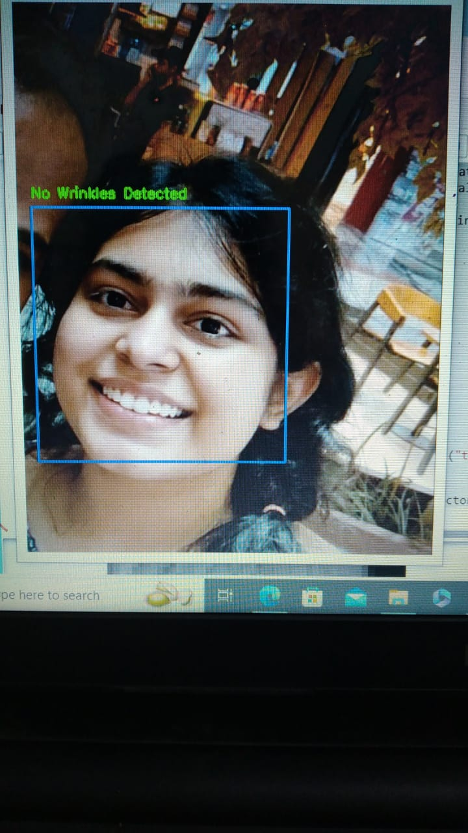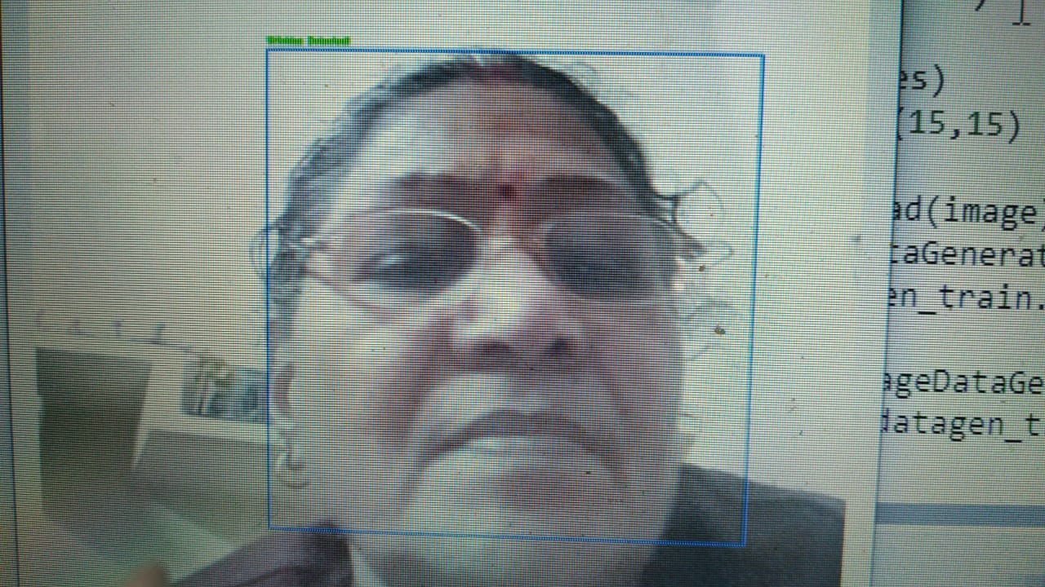

No wrinkles detected | Wrinkles Detected

* **Real-time Emotion Detection:**
  + Utilized pre-trained models and datasets for facial expression recognition.
  + Developed custom deep learning models for real-time emotion detection from video streams.
  + Used Deepface Library to detect emotions in realtime.
  + 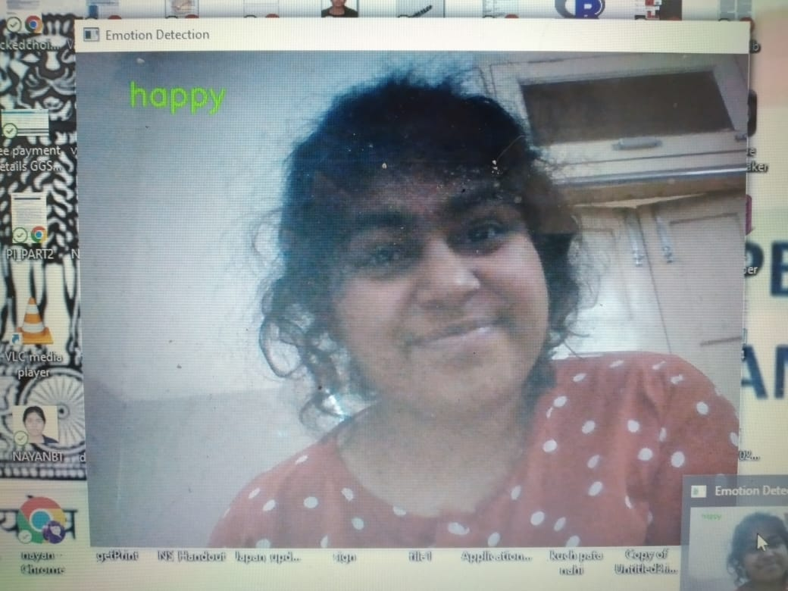
  + Detected emotion in each frame of the video and also found out the dominant emotion in the entire video stream.

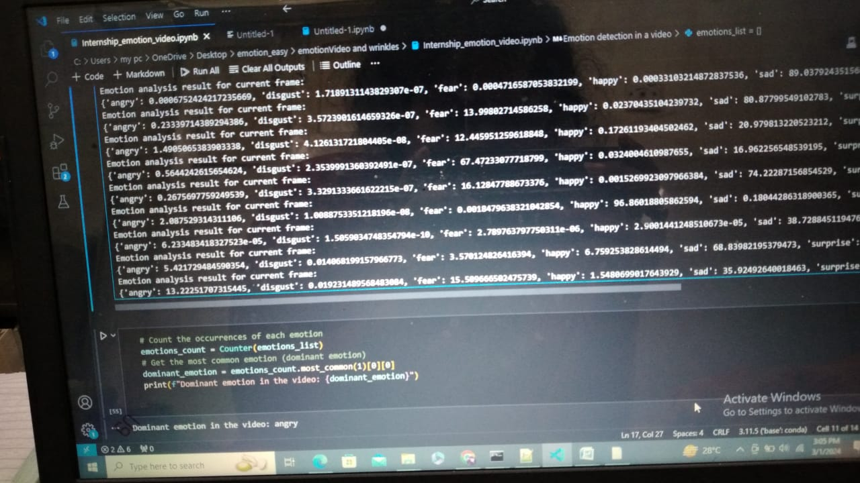

* **Voice Tone Analysis:**
  + Researched signal processing techniques for voice tone analysis.
  + Integrated voice tone analysis with the existing emotion detection pipeline.
  + Used SpeechRecognition library along with deepface library to detect emotions.
* **Drowsiness Detection:**
  + Investigated computer vision algorithms for eye state detection.
  + Designed a real-time drowsiness detection system based on eye state analysis.
* **Multimodal Emotion Detection:**
* Real-time emotion recognition using webcam and microphone inputs.
* Integration of facial expression recognition and speech emotion analysis modules.
* Enhancement of emotion detection accuracy through multimodal fusion techniques.
* 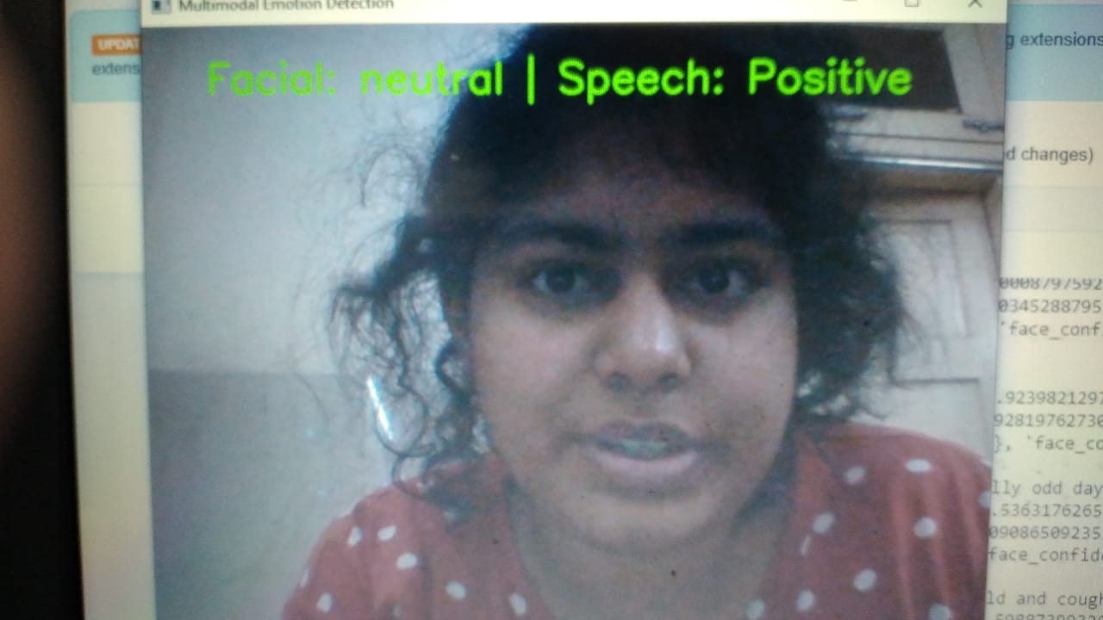
* The integration of facial expressions and speech analysis offers several advantages over unimodal approaches. Facial expressions provide valuable cues about a person's emotional state, while speech patterns convey additional emotional information. Previous research has demonstrated the effectiveness of multimodal emotion detection systems in capturing complex emotional states and improving overall recognition accuracy. Leveraging advancements in machine learning, computer vision, and signal processing, our system aims to harness the power of multimodal data for accurate and efficient emotion recognition.

**Skills and Competencies:**

1. Proficiency in Python programming language.
2. Knowledge of computer vision and machine learning algorithms.
3. Experience with deep learning frameworks such as TensorFlow and Keras.
4. Strong analytical and problem-solving skills.
5. Ability to work with large datasets and real-time data streams.

**Feedback and Evidence:** Regular feedback sessions with mentors and peers helped in refining the project objectives and methodologies. Code reviews and project demonstrations provided valuable insights into improving the implementation and performance of the emotion detection systems.

**Challenges and Solutions:**

1. Limited availability of annotated datasets for specific tasks required data augmentation and transfer learning techniques.
2. Processing real-time video streams posed challenges in terms of computational efficiency and latency, addressed by optimizing algorithms and hardware acceleration.
3. Integrating voice tone analysis with facial expression recognition required synchronization and fusion of heterogeneous data streams.

**Outcomes and Impact:**

1. Successfully developed a wrinkle detection algorithm with high accuracy.
2. Implemented real-time emotion detection systems capable of identifying predominant emotions in video streams.
3. Integrated voice tone analysis to enhance emotion recognition accuracy.
4. Designed and deployed a drowsiness detection system with satisfactory performance.

**Conclusion:** The internship provided valuable hands-on experience in developing real-time emotion detection systems using computer vision and machine learning techniques. The acquired skills and knowledge are applicable across various domains, including healthcare, automotive safety, and human-computer interaction. The internship experience significantly contributed to personal and professional growth, paving the way for future endeavors in the field of artificial intelligence and human-computer interaction.

Top of Form